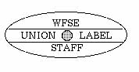
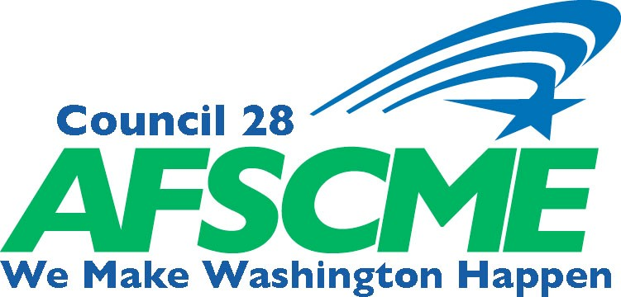
WASHINGTON FEDERATION OF STATE EMPLOYEES
WFSE/AFSCME ! AFL-CIO STATE HEADQUARTERS OFFICE
1212 JEFFERSON ST. S.E. SUITE 300, OLYMPIA WA 98501
(360) 352-7603 ! (800) 562-6002 ! FAX (360) 352-7608

June 2019

TO: Local Union Officers

FROM: Liz Larsen, Director of Administration

SUBJECT: Printing & Mailings of Local Union Notices/Flyers/Newsletters

The following outlines the procedure for submitting requests for printing and mailing Local meeting notices, flyers, newsletters, etc. We have enclosed a breakdown of the current costs of postage, printing materials and bindery and have included the cost of printing in color.

PROCEDURE FOR SUBMITTING PRINTING AND/OR MAILING REQUESTS

Please direct all requests for Local Union printing and/or mailings to our new Local Printing & Mailing request email address: LocalPrintMail@wfse.org. Please indicate your Local number and the word “Print” in the subject line of your email. Printing and mailing requests are handled by our Senior Printer, Brandon Day in the Olympia Headquarters office. Brandon is available from 8:30 AM - 5:00 PM Monday through Friday.

In order to be able to mail your meeting notice, flyer or newsletter as quickly as possible, we ask that you submit your documents print-ready via email. We have meeting notice templates available to download on our website for your convenience http://wfse.org/locals/meeting-notice-templates/. If you have difficulty downloading or using any of our templates, please contact your local field office. We encourage you to work with your Council Representative and local field office staff in order to ensure your document is print ready and that dates, times and agenda items are correct as well as all timelines meet AFSCME and your Local’s constitution requirements for notification of elections, etc.

Once your print-ready document is received, we will send a confirmation email informing you of the approximate day your meeting notice, flyer or newsletter will be mailed or available for pick up. If there are any questions or your document is not print-ready, you may be contacted.

Timelines:
- Meeting Notices/Event Flyers
Will be mailed within three (3) business days of receipt of a print-ready document.

Newsletters
Will be mailed within five (5) business days of receipt of a print-ready document.

Color Print Requests:
If you request that your notices, newsletters, etc., be printed in color, please add an additional
two (2) days to the above timelines.

Brandon and your field staff are working closely together on this process and will make every effort to print and mail your documents according to the timelines above. However, due to periodic high volumes of both local and council print jobs, we may not be able to meet all of your expectations. In those instances, you will be contacted to discuss options.

Local meetings and events will also be placed on the WFSE.org and Local LaborWeb online calendars (for those locals subscribed to LaborWeb) when mailed.

Staff in the WFSE print shop are OPEIU Local 8 members. Union-organized paper manufacturers make the majority of the paper we purchase locally. The OPEIU Local 8 union bug will be included on all print jobs. Locals are encouraged to only patronize union printers.

The cost for printing and mailing notices, flyers, newsletters, etc., will be deducted from your Local per capita each month. A detail of the charges and copies of the printed items will be included with the report. The prices for printing and mailing are included with this memo.

If you have any questions or concerns regarding these procedures, please give me a call at: 1-800-562- 6002 or email me at: lizl@wfse.org.

Thank you.

Encl: Printing and Mailing Cost sheet WFSE Policy on Union Labeling

WFSE PRINTING AND MAILING COSTS AS OF JANUARY 2015
All printing and mailing costs include materials and labor.

POSTAGE PER PIECE
1ST CLASS LETTER $0.50
1ST CLASS POST CARD $0.35
AVERAGE STANDARD BULK RATE+ $0.17+ based on zip codes
BUSINESS REPLY #9 $1.29 * ($0.50 Postage + $0.79 USPS Handling Charge) BUSINESS REPLY POST CARD $1.14 * ($0.35 Postage + $0.79 USPS Handling Charge)
+ Bulk mail rates may be less based on the zip sort of each mailing list. Bulk rates apply to 200 or more pieces.
* Locals are only charged for envelopes/postcards that are returned to WFSE.

ENVELOPES | EACH
WFSE LOGO #10 | $0.07
WFSE LOGO 10X13 | $0.51
BALLOT ENCLOSED #8 | $0.10
BUSINESS REPLY #9 | $0.08

HANDLING CHARGE FOR ALL PRINTING $10.00

PRINTING COSTS
PAPER USED COST PER SHEET
8.5" x 11" STANDARD 20# Black ink: 4 Cents Color ink: 10 Cents
8.5" x 11" STANDARD 70# Black ink: 5 Cents Color ink: 11 Cents
8.5" x 11" BRIGHT “ULTRA” COLOR 60# Black ink: 6 Cents Color ink: 14 Cents
8.5" x 11" CARD STOCK 110# Black ink: 6 Cents Color ink: 14 Cents
8.5" x 11" LETTERHEAD WHITE 24# Black ink: 7 cents
8.5" x 14" STANDARD 20# Black ink: 4 Cents Color ink: 12 Cents
8.5" x 14" STANDARD 70# Black ink: 5 Cents Color ink: 13 Cents
11" x 17" STANDARD 60# Black ink: 6 Cents Color ink: 14 Cents
11" x 17" STANDARD 70# Black ink: 7 Cents Color ink: 15 Cents (Add 2.5 cents for printed second side in Black ink. Add 9 cents for Colored ink.)
All paper is at least 30% post consumer waste-recycled stock.

BINDERY (Per 1000)
FOLD $5.00
CUT $5.00
TABBING (tri-folds & folded flyers) $40.00/1000
ADDRESSING $45.00 Includes mail processing
INSERT (envelope stuffing) $80.00 First piece per 1000;
each additional insert piece is $15.00 per 1000

