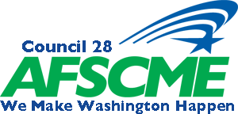
USA Policy Committee Meeting
Saturday April 27, 2019- 11am at the Doubletree, SeaTac
Washington Federation of State Employees
AGENDA

1. Call to Order

2. Roll Call of Officers and Delegates

3. Approval of Minutes from January’s Meeting

4. 100% Union Discussion

5. Special Order of Business: Elections
Nominations and Elections for 1 Vacant Board Position

6. PEOPLE

7. Executive Board Member reports

• Jeff Paulsen
• Brooks Salazar
• Linda Erickson
• Scott Mallery
• Wendy Conway
• Terry Nixon
• Ben Olsen

8. New Business (including any resolutions from Locals)

9. Old Business

10. Good & Welfare

11. Adjournment

