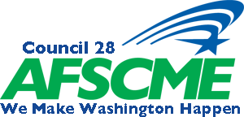
Transportation Policy Committee Meeting
Saturday April 27, 2010-11am at the Doubletree, SeaTac
Washington Federation of State Employees
DRAFT AGENDA

1. Call to Order

2. Roll Call of Officers and Delegates

3. Approval of Minutes from January’s Meeting

4. PEOPLE

5. 100% Union Discussion

6. Executive Board Member reports

• Steve Fries
• Kenneth Harmon- Brown
• Sam Schneider
• Georgina Willner

7. UMCC, Bargaining and Demand to Bargain Reports

8. New Business (including any resolutions from Locals)

9. Good & Welfare

10. Adjournment

