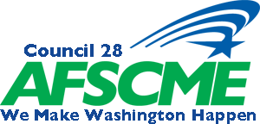
Labor and Industries Policy Committee Meeting
Saturday April 27,2019 – 11am at the Doubletree, SeaTac
Washington Federation of State Employees
DRAFT AGENDA

- Safety

- Call to Order

- Roll call of Officers and Delegates

- Approval of Minutes from January’s Meeting

- PEOPLE

- 100 % Union Discussion

- Executive Board Member reports

  - Nikki Butler
  - Deborah Haigh
  - Carmyn Shute
  - Ken Grubb

9. UMCC Reports

10. New Business (including any resolutions from Locals)

11. Good & Welfare

12. Adjournment

