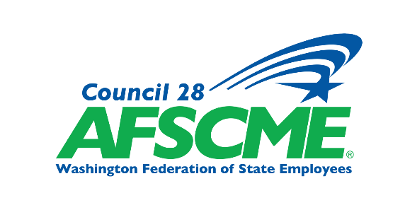
Summary of Tentative Agreement
Reached for 2026-2028 TCC Exempt CBA
This is a summary that highlights and explains the most significant provisions of the Tentative Agreement (TA) reached between the Washington Federation of State Employees (WFSE) and Tacoma Community College Exempt CBA (TCC Exempt). It does not cover every article nor every provision.
Read the complete Tentative Agreement document on the WFSE website.

MAJOR GOALS
Major goals achieved include:
- Despite a challenging budget outlook from the Washington State Legislature the contract secures a general wage increase of 2% July 1, 2026
- New retention incentive: $3,000 added to base salary on reaching three years of service
- Increase to education pay, from $650 to $1500 for earning a relevant master’s degree
- Plus, many more economic and non-economic improvements! See the full tentative agreement for details.

Union Members - Please VOTE to ratify this agreement!
Your TCC Exempt Bargaining Team recommends you
VOTE YES TO ACCEPT this Agreement!

COMPENSATION HIGHLIGHTS
See Major Goals won on page 1 of this summary! In addition to all of those incredible gains, we achieved:
Article 40 Compensation
- General wage increase of 2% July 1, 2026 and language guaranteeing a reopening of negotiations on compensation for 2027 and 2028.
- Increase to educational pay from $650 to $1,500 for those with a relevant master’s degree.
- Creation of an all-new pay category, a retention incentive of $3,000 added to base salary when an employee reaches three years of service.
NON-COMPENSATION HIGHLIGHTS
Article 2 – Non-Discrimination
- Extends discrimination protections to chest feeding parents
Article 5 – Workplace Behavior
- Establishes a practice for the college to make mediation available for dispute resolution.
Article 6 – Hiring and Appointments
- Guarantees that employees with the skills and abilities for an open position in the bargaining unit will receive an interview.
Article 7– Hours of Work and Overtime
- Establishes standards for overtime eligible employees including a 40 hour work week and two consecutive days off.
Article 8 – Training and Employee Development
- Replaces “Master Agreement” with “Collective Bargaining Agreement”
Article 9– Deductions and Status Reports
- Matches Classified contract regarding information shared with Union
Article 11 – Employee Files
- Reduces time that disciplinary records stay in personnel files from 5 years to 3.
Article 13 – Annual Leave
- Increases vacation leave cap to 280 hours instead of 240
Article 14 – Sick Leave
- Allows for use of sick leave to participate in immigration proceedings
Article 19 – Suspended Operations and College Closures
- Allows employees up to one (1) hour of paid time if reporting to work late due to inclement weather or a natural disaster.
Article 25 – Commute Trip Reduction, Telework, Flex Time, Compressed Workweek, and Parking
- Makes permanent the provision of two (2) free parking permits per employee annually

Your TCC Exempt Bargaining Team recommends you
VOTE YES TO ACCEPT this Agreement!

Not a member, but want to vote? It’s not too late!
You can join here: Join | AFSCME Council 28 (WFSE)

