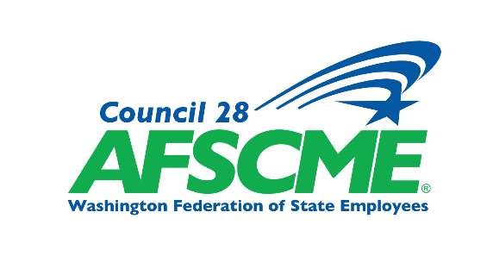
Summary of Tentative Agreement
Reached for 2025-2027 SPSCC Exempt CBA
This is a summary that highlights and explains the most significant provisions of the Tentative Agreement (TA) reached between the Washington Federation of State Employees (WFSE) and South Puget Sound Community College Exempt CBA (SPSCC Exempt). It does not cover every article nor every provision.
Read the complete Tentative Agreement document on the WFSE website.

MAJOR GOALS
Major goals achieved include:
- Despite a challenging budget outlook from the Washington State Legislature the contract secures a general wage increase of 3% July 1, 2025 and 2% July 1, 2026.
- Preserves the 15%/85% Health Care Premium split and adds Employer-Paid stand-alone Vision Benefit
- Increases minimum base salary to $68,000
- Plus, many, many more economic and non-economic improvements! See the full tentative agreement for details.

Union Members - Please VOTE to ratify this agreement!
Your SPSCC Exempt Bargaining Team recommends you
VOTE YES TO ACCEPT this Agreement!

COMPENSATION HIGHLIGHTS
See Major Goals won on page 1 of this summary! In addition to all of those incredible gains, we achieved:
Article 40 Compensation
- General wage increases of 3% July 1, 2025 and 2% July 1, 2026.
- Preserves 5% split of the operating budget close
- Protects salary steps of $1250 in years 3, 5, and 8
NON-COMPENSATION HIGHLIGHTS
Article 1 – Union Recognition
- Adds Learning Support Services Administrators to the Bargaining Unit
Article 2 – Non-Discrimination
- Extends discrimination protections to chest feeding parents as well as for HIV/AIDS status, Hepatitis C status and “any other legally protected class.”
Article 5 – Workplace Behavior
- Establishes right to a summary of investigation(s) into complaints of others’ behavior
Article 6 – Hiring and Appointments
- Guarantees right to notice and review of priorities, duties, and expectations in your work
Article 7– Hours of Work and Overtime
- Establishes standards for overtime eligible employees including a 40 hour work week, two consecutive days off, and 28 days’ notice of schedule changes.
Article 8 – Training and Employee Development
- Replaces “Master Agreement” with “Collective Bargaining Agreement”
- Guarantees a minimum of two institutional memberships
- Increases minimum training dollars pool to $20,000 and excludes overtime costs from coming out of that pool
Article 9– Deductions and Status Reports
- Matches Classified contract regarding information shared with Union
Article 10 – Performance Evaluation
- Reduces time performance evaluations stay in personnel files from 5 years to 3.
Article 13 – Vacation Leave
- Requires an official explanation for cancelled vacation leave
- Increases vacation leave cap to 280 hours instead of 240
Article 14 – Sick Leave
- Expands sick leave use for work or school closures due to natural disaster or public health emergency
- Incorporates new family definitions for sick leave purposes, including language which adds, “household members”
Article 15 – Shared Leave
- Memorializes ability to transfer leave to another state agency, higher ed institution, school district, or educational service district
Article 16 – Miscellaneous Paid Leave
- Extends bereavement leave use to sick leave use
- Creates three days of leave to visit with the Employee Assistance Program
Article 20 – Compensable Work-Related Injury or Illness
- Allows for schedule adjustments instead of leave use to attend medical appointments
Article 23 – Safety and Health
- Establishes option to telework if exposed to serious contagious health condition but still able to work
Article 30 – Corrective Action, Discipline, and Discharge
- Right to notification if under investigation unless notification would jeopardize an investigation

Your SPSCC Exempt Bargaining Team recommends you
VOTE YES TO ACCEPT this Agreement!

Not a member, but want to vote? It’s not too late!
You can join here: Join | AFSCME Council 28 (WFSE)

